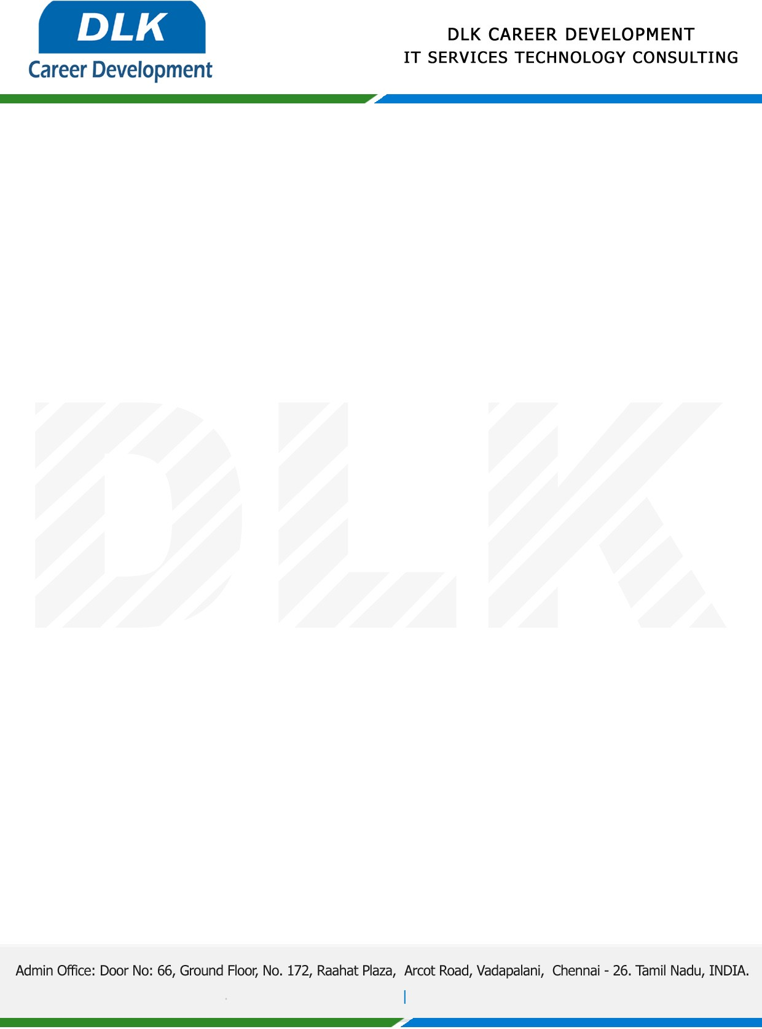

**Date: 12/ May /2023**

**SUB: PROJECT COMPLETION CERTIFICATE**

This is to certify that **MR SYED LUKMAN S N (REG NO: 201371601075) BSC- Computer Science,** final year student **B.S. Abdur Rahman Crescent Institute of Science and Technology, Chennai** has Successfully Completed the Project Work under the domain of “**Java”** in our organization during the Period **(20th January 2023 to 10th May 2023).**

**Topic:** Reliable Transmission of Clinical Data Using Proxy Re-Encryption.

We appreciate your interest in **DLK CAREER DEVELOPMENT**

**“Best Wishes for Your Future Endeavors “**

